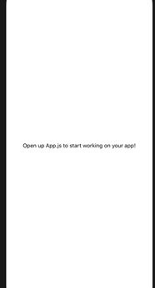

# code

import React from 'react';

import { StatusBar } from 'expo-status-bar';

import { StyleSheet, Text, View } from 'react-native';

export default function App() {

return (

<View style={styles.container}>

<Text>Open up App.js to start working on your app!</Text>

<StatusBar style="auto" />

</View>

);

}

const styles = StyleSheet.create({

container: {

flex: 1,

backgroundColor: '#fff',

alignItems: 'center',

justifyContent: 'center',

},

});